The DownEast Schooner
26' gaff-rigged schooner
Two articles, one a brochure piece, the other from a magazine

SMALL TALK -- Small Schooner
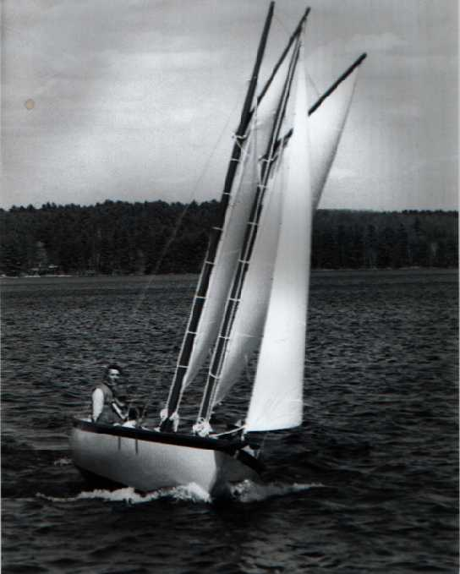
"A schooner rig (of the coaster or pilot boat type) is the handsomest rig there is," the late Pete Culler once wrote, and there are many who agree with him. But Culler added that he didn't think the schooner rig was suitable for craft under 40'. That leaves out a lot of us schooner fanciers when it comes to any realistic dreams of skippering a schooner of our own.
Nevertheless, the schooner dream persists, and designers from time to time try to fulfill it for those of us who can never hope to own a 40-footer. The latest effort to produce an affordable tabloid schooner turned up last winter at Boston's Commonwealth Pier Boat Show where it immediately excited this schooner buffs imagination.
The Down East Schooner is only 22'6" l.o.a. not counting the 31/2"bowsprit, l8'4"l.w.l., with 7'4" beam, a draft of 3' and an enormous open cockpit, 9, long. She's sturdily built of hand-laid fiberglass, displacing 4,160 lb., with 1,640 lb. of lead inside the fiberglass keel. Two 21'Awlgrip alumimum spars carry 242-sq. ft. of sail. She looked mighty handsome there, among the sloops and cats in the small sailboat section of the Boston show.
But handsome is as handsome does. So as soon as the weather warmed up and this prototype boat was overboard, I flew down to Rye, New Hampshire, to try her out with her designer, Chuck Paine, and her builder, Bill Cavanaugh of Mark Marine Inc. in nearby Raymond, New Hampshire.
Cavanaugh is another schooner dreamer, a former contractor who started building boats a few years ago because he thought he could build them better. A little trading schooner caught his eye while he was vacationing in the Caribbean last year, and he sent a picture of her to Paine.
"Design for me a little daysailer that looks like that," were his instructions. The result was a little ship with a nice traditional look above the waterline and very pleasing lines below - lines that could make one think of Nathanael Herreshoff; quite rightly so. The underbody of the Down East Schooner is essentially that of a stretched-out Herreshoff l2 - 1/2, which Paine regards as an almost perfect hull from a design genius.
The question was, would this little schooner perform as well as Herreshoff's little gem - fast, responsive and forgiving? And what about all those strings to pull? Would the complications of the schooner rig be a nuisance on such a small craft?
We soon found out. Snapping on the jib and hoisting main and mizzen took only a few minutes. I've spent as much time getting a sloop of the same size ready to cast off. Against my better judgment, we didn't tuck in any reefs although the wind was gusting up to around 25 m.p.h. A full blast swept the harbor as we cast off, filled away and threaded agilely through a tightly packed fleet of lobster boats. Her designer, at the helm for the first time, let her fall off before it, gybed the foresail and ran out of the narrow harbor entrance, wing and wing, at about six knots, something over hull speed. Paine grinned. It was beginning to feel as though she'd be a handsome boat to sail as well as to look at.
I got my turn at the helm as we sheeted in for a long beat along the New Hampshire coast. I still think she could have stood the reefs in that wind. Or we might have just dropped the foresail, as Cavanaugh said he had done in even heavier winds the week before. He said she settled down and balanced nicely. But even over-canvassed, she stood up well to the gusts that assailed us and bowled along at a fine clip. In the heaviest air, I found it expedient to carry a luff as we put the rail down and the water edged up to where a cockpit coaming should be - but isn't on this first-off boat. Later models will have a 4" coaming of African teak.
Though she has a good-sized foredeck and a mammoth - 7'- afterdeck, this boat is all open, with no flotation. She'd go down like a rock if she were flooded, so some prudence is called for under such conditions.
She's reasonably dry. What little spray we caught, hit only the forward part of the cockpit. I think there will be a demand for a little cuddy to crawl under. I think I'd build in some lockers under the forward and after decks, for safe storage and to reduce the danger of a swamp-out.
But Cavanaugh is trying to keep her simple and inexpensive - a schooner poor dreamers can afford. At $9,500, he's doing very well, it seems to me. People with big dreams - of coastal cruising, for example - can make their own modifications. A cockpit tent, which also can serve as a dodger when partially folded, is one option already planned.
She tacked smartly and we roared off up the coast on a broad-reach. As we approached Rye Harbor, Cavanaugh started fumbling with a small outboard motor he had stowed under the afterdeck. It was a dead beat into the harbor and the tide was running against us. But Paine would have none of motoring. Although he was dissatisfied with the jib trim, which is to be changed, he was determined to tack her home. And tack her he did, right through the narrow breakwater entrance, right up through the closely packed fleet; and then he laid her quietly alongside the float.
Smart seamanship. Smart boat.

- Jim Brown

SMALL BOAT JOURNAL October/November 1981

"The performance of this boat surprises even me. She is very fast indeed, and has a wonderfully light feel to the helm. While schooners are well known to be fast on a reach, I find no deficiencies to her windward ability, and we discovered the two boomed sails to be a great way of projecting a lot of usable sail area when well off the wind. I love the look of the boat with her sheer and wineglass sections. All in all, she illustrates the difference between 'classic' and 'character' boats, being both lovely to look at and a sparkling performer to boot.  Chuck Paine, C W Paine Yacht Design, Inc. | 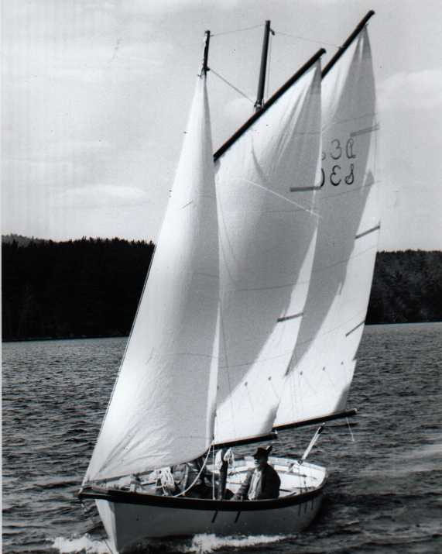

This beautiful daysailing version of the schooners that plied our New England waters with lithesome grace and storied ability was the result of Mark Marine and Chuck Paine. N.A blending modern materials and traditional design. Mr. Paine, who resides in Camden, Maine, is known world wide for his many successful traditional designs, among them the "Annie," the "Frances," and the "Sarah" whose beauty and sailing abilities have been written about in virtually every sailing chronicle. A man who calls himself "a former engineer with the heart of an artist," Mr. Paine is uniquely qualified in his field.

The" Down East Schooner" is built of solid fiberglass with end-grain balsa to provide additional stiffening in her deck and cockpit sole. She is internally ballasted with lead carried deep in her full keel. Cockpit seats are molded in port and starboard and are trimmed in Iroko. Iroko is also used for the sheerline, interior trim and her impressive bowsprit. All horizontal surfaces are molded in non- skid. Her American made dacron sails are hung on Awlgrip aluminum spars and fastened with stainless steel rigging. Deck hardware on the "Down East Schooner" is bronze with bronze chainplates. Main, fore and jib are standard.

This exceptionally seaworthy and stable sailer carries six to eight people in her deep roomy cockpit in full comfort An optional canvas cuddy, which can be up when sailing, offers protection from wind and rain. Her wide fore and aft decks are ideal for sunbathing and fishing. She provides ample storage both fore and aft for sails, life preservers and other sailing gear.

The "Down East Schooner" is a delight to sail in all sea conditions. She is easily handled and always responsive. Both the fore and main carry reef points, but the sail area is easily reduced by lowering either the main or the foresail without affecting helm or balance.

The "Down East Schooner" is the ideal boat for coastal cruising, family outings, excursions and sightseeing She is easily launched and trailered Her traditional gaff rig, graceful sheer and New England craftsmanship make her the center of attention in every harbor.

